**Practical:-1**

**Aim:** **Create your profile on social site. You may create two or more HTML pages. Your**

**Page mast include various sections (personal info, messages, photos etc.**

**Program code:**

1. **Page1.html**

<html>

<head>

<title>

**Twitter**

</title>

</head>

<body background=**"monster.jpg"**>

<h2 align=**"center"**>**Profile**</h2>

<fieldset>

<legend><h2>**Personal info**</h2></legend>

<img src=**"images.jpg"** width=**"10%"** heigth=**"10%"**>

<h3>**Name:HETVI MISTRY** </h3>

<h3>**Mob No:8905461705**</h3>

<h3>**Email Id: hetvimistry21@gmail.com**</h3>

<h4> **For More Personal Details**<a href=**"page2.html"**>**Click here**</a></h4>

</fieldset>

<fieldset>

<legend><h2>**About Me**</h2></legend>

<p>

**I am pursuing my Computer Science engineering. I hate coding but love it when I succeed with successful program output. I hope for the good job ahead in which I can get through emerging technologies and knowledge as well and wish to fulfil their requirements.**

</p>

</fieldset>

<fieldset>

<legend><h2>**Qualification**</h2></legend>

<table border=**"1"**>

<tr>

<th>**Degree**</th>

<th>**School/Institute**</th>

<th>**Board/University**</th>

<th>**Year**</th>

<th>**%Marks**</th>

</tr>

<tr>

<td>**S.S.C**</td>

<td>**Baroda High School(O.N.G.C)**</td>

<td>**GSEB**</td>

<td>**2010**</td>

<td>**82%**</td>

</tr>

<tr>

<td>**H.S.C**</td>

<td>**Baroda High School(O.N.G.C)**</td>

<td>**GSEB**</td>

<td>**2012**</td>

<td>**62%**</td>

</tr>

<tr>

<td>**B.E in CSE**</td>

<td>**BITS EDU CAMPUS**</td>

<td>**G.T.U**</td>

<td>**2017(Expected)**</td>

<td>**7.67cpi**</td>

</tr>

</table>

</fieldset>

<fieldset>

<legend><h2>**Areas of interest**</h2></legend>

<ul>

<li>**Reading**</li>

<li>**Travelling**</li>

<li>**Drawing**</li>

<li>**Badminton Sport**</li>

</ul>

</fieldset>

<fieldset>

<legend><h2>**Achievements**</h2></legend>

<ul>

<li>**I have achieved an award for 1st position in Idea Presentation event of CSI.**</li>

<li>**I have achieved certificates for quiz competition of CSI events.**</li>

</ul>

</fieldset>

<h4 align=**"right"**><a href=**"#TOP"**>**Go to top**</a></h4>

</body>

</html>

1. **Page2.html**

<html>

<head>

<title> **details info**</title>

</head>

<body background=**"monster.jpg"**>

<table border=**"1"** align=**"center"** width=**"95%"**>

<center>

<tr>

<td>**Full Name:**</td>

<td>**Hetvi Paresh Mistry**</td>

</tr>

<tr>

<td>**Date Of Birth:**</td>

<td>**21-09-1995**

<tr>

<td>**Address:**</td>

<td>**b-25, Amrut Nagar soc.,Opp. Novino, Baroda.**</td>

</tr>

<tr>

<td>**Gender:**</td>

<td>**Female**</td>

</tr>

<tr>

<td>**Education:**</td>

<td>**Computer Science** & **Engineering-3rd yr**</td>

</td>

<tr>

<td>**Languages Known:**</td>

<td>**English,Hindi,Gujrati**</td>

</tr>

</table>

<a href=**"page1.html"**>

<p><h2 align=**"left"**>**Return to Profile**</h2></p></a>

</center>

</body>

</html>

**Output:**

1. **Page1.html**

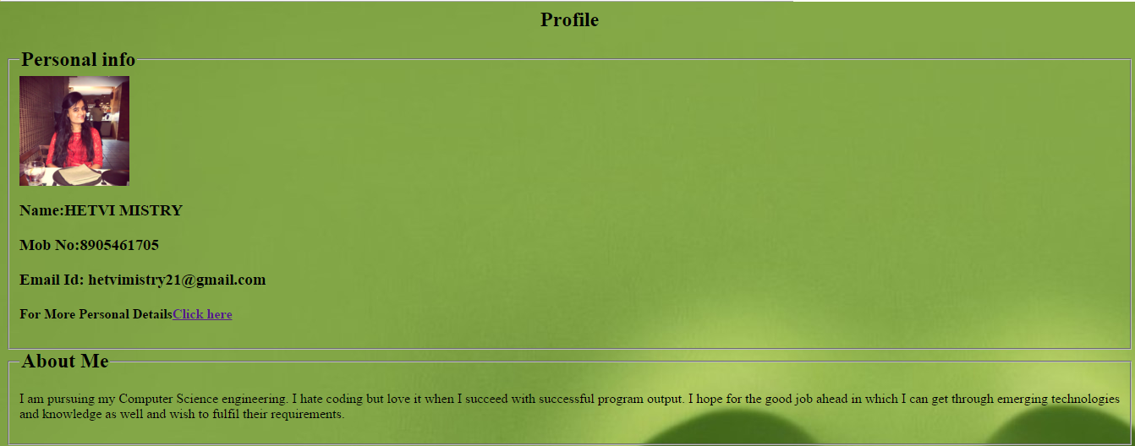

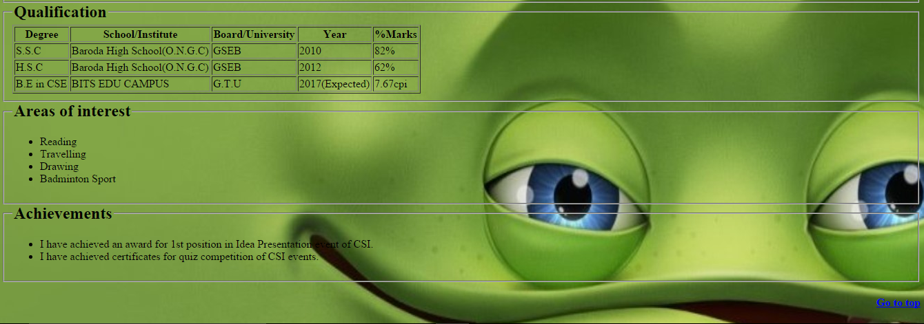

1. **Page2.html**

